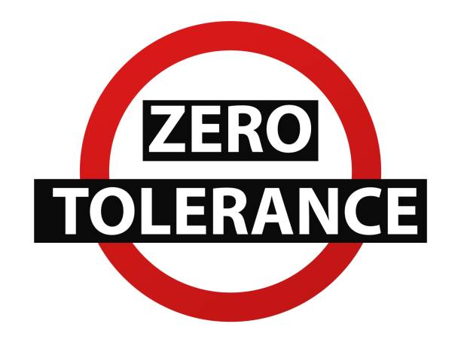

LOGAN PRACTICE HAS A ZERO TOLERANCE POLICY
THE FOLLOWING (BUT NOT LIMITED TOO) WILL NOT BE ACCEPT
AND MAY RESULT IN A REMOVAL FROM OUR LIST

- Offensive language, verbal abuse & swearing
- Physical violence towards staff or other patients
- Racial abuse or sexual harassment
- Unwanted or abusive remarks or gestures
- Brandishing of objects or weapons
- Intimidation
- Unreasonable behaviour and non-cooperation
- Threats or risk of injury to staff
PLEASE BE KIND TO OUR STAFF

